**JMeter:**

The Apache JMeter is Java based software, designed load testing and functional testing of web servers and applications. Performance testing is testing a web application against heavy load, multiple and concurrent user traffic. JMeter is used for functional test, database server test also.

JMeter can be run in both GUI Mode and also in command-line mode.

A simple test plan can be created for load testing on [www.google.com](http://www.google.com) in the following steps:

* Open Jmeter.bat to start JMeter in GUI Mode
* Rename the Test Plan as you like(can only be seen renamed when you shift focus to workbench tab and then to Test Plan) 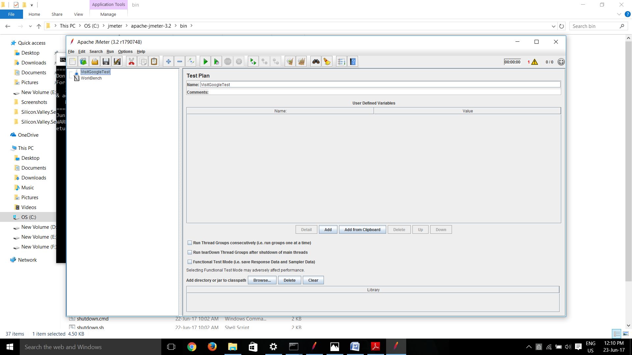
* Right Click on Visit Google Test -> Add -> Thread(Users) -> Thread Group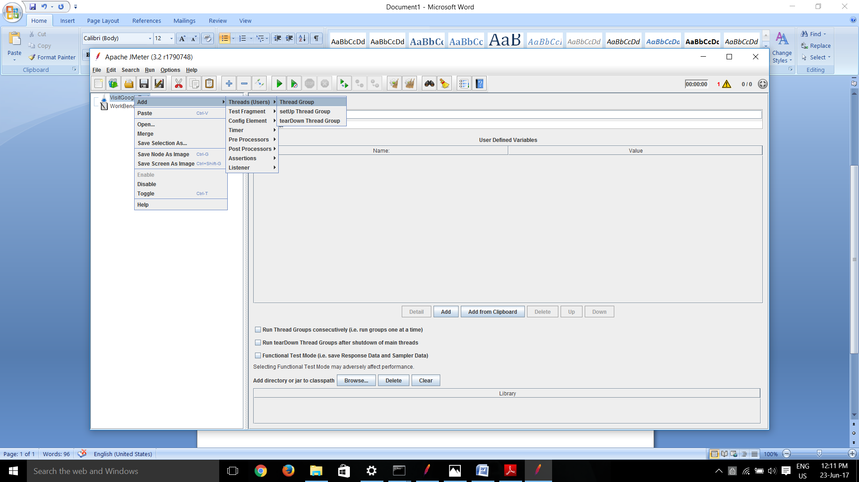

This will create a User group which will be used for setting the threads(users) for load testing.

Rename the group as you wish

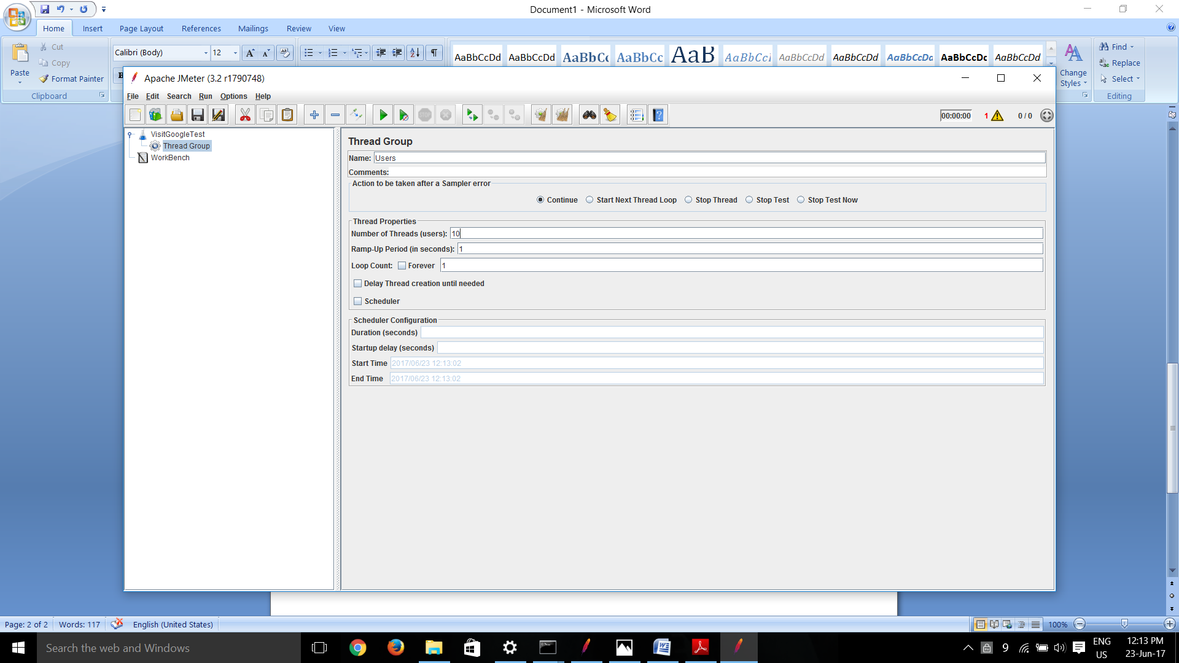

Thread Properties:

Number of Threads(Users): This is the number of threads/users which will be simultaneously doing the HTTP,JDBC, FTP …,etc requests for testing. Eg.: For 10 users set this value to 10

Ramp-Up Period : Time between the triggering of threads.

Loop Count: How many times the threads will run.

* For testing a particular server add Sampler (Right Click on Users -> Add -> Samplers) of required type. E.g.: HTTP request(In this case), JDBC request, JUnit request etc…..

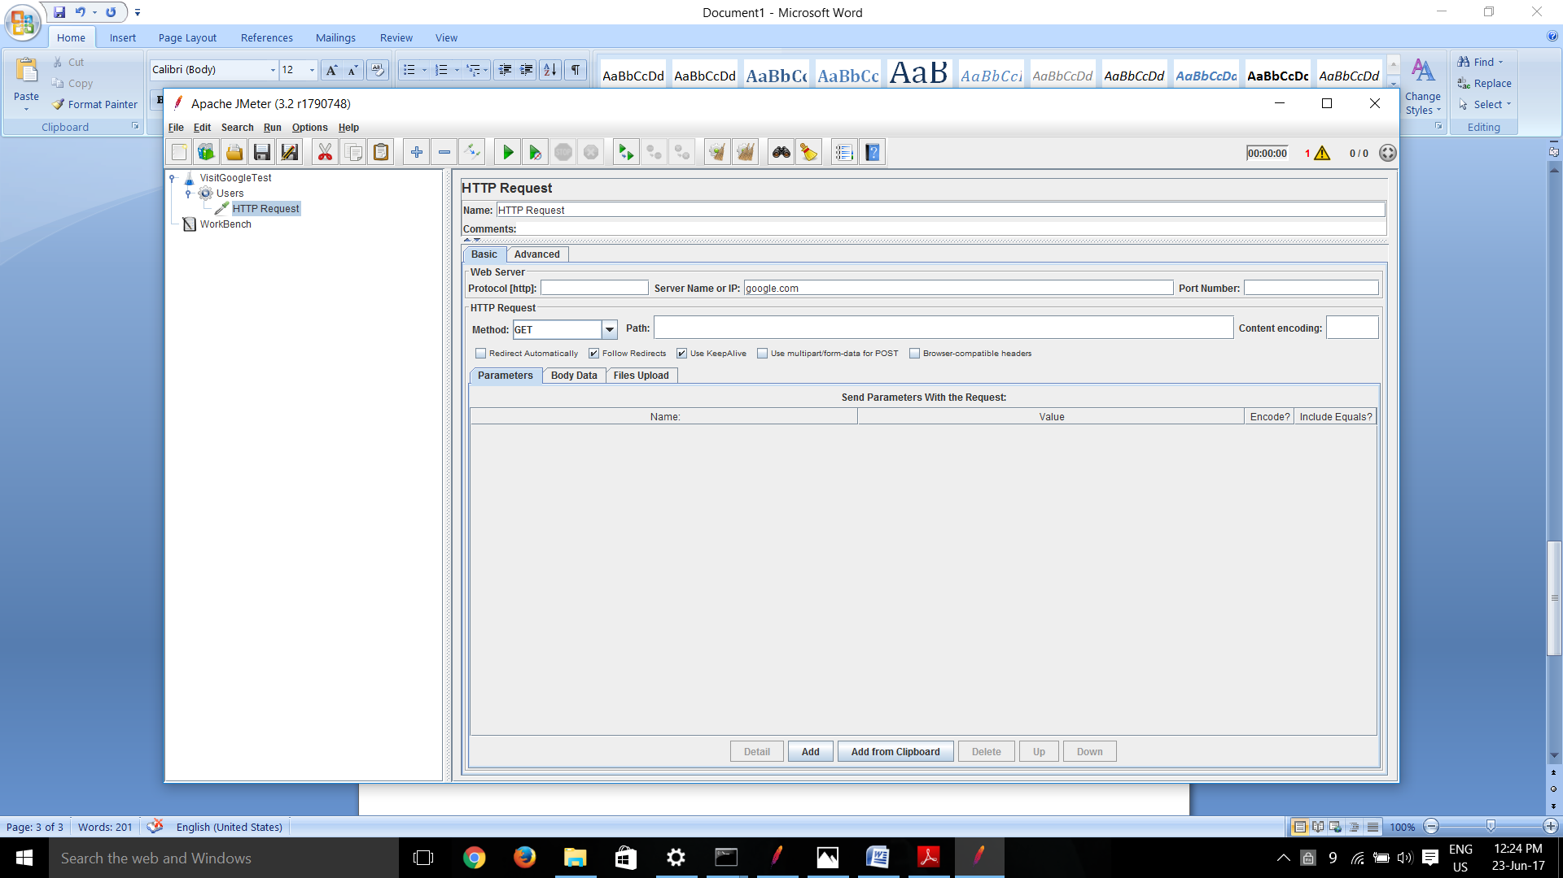

Server Name or IP: Name of the server you want to test

Path: if you want to go to relative page from the server name

Protocol: Blank for HTTP

Method: GET/POST/etc.

* For results add listener(Right Click on Users -> Add -> Listeners)

Listeners are of various forms which can be represented in the form of a tree, summary report, aggregate report, table etc….

For this test case, we added Result Tree which can be seen in below screenshot with the details of every request for every thread.

